PROJECT REPORT
- Introduction to Embedded Systems
  - What is an Embedded System?
- An embedded system is a computer-based electronic system built to perform one specific function or a set of dedicated functions, unlike general-purpose computers.
- It is optimized for a particular task rather than running many different applications.
- Includes a microcontroller/microprocessor, memory, sensors, actuators, and communication interfaces.
- Controls the hardware's operation and implements the required functionality.
- Fast response, low power consumption, reliability, compact size, and cost-effectiveness.
- Used in automotive ECUs, medical monitoring devices, smart home appliances, industrial controllers, wearables, and robotics.

  - Basic Components of an Embedded System
- Microcontroller/Microprocessor: Acts as the processing unit of the system. It executes the program and controls other components.
- Memory: Stores the program instructions and data required during system operation.
- Sensors: Collect information from the physical environment.
Examples: Temperature sensor, Motion sensor.
- Actuators: Convert electrical control signals into physical actions.
Examples: Motors, Relays.
- Communication Interfaces: Allow the embedded system to communicate with other devices.
Examples: UART, SPI, I²C.

  - Characteristics of Embedded Systems
- An embedded system is generally designed for a specific application.
- Many embedded systems need to respond to inputs within a specified time.
- Many embedded devices operate using batteries or have strict power requirements.
- Embedded systems are often expected to operate continuously and reliably.
- Embedded systems are designed to fit within larger products or devices.
- Microcontrollers and dedicated hardware allow embedded systems to be implemented at relatively low cost.
- The hardware and firmware are designed to work together for a specific application.

  - Real-World Applications of Embedded System
- Smart Home:
Embedded systems are used in: Smart lighting, Smart thermostats, Security systems, Smart door locks, home automation.
- Automotive
Modern vehicles contain numerous embedded systems, including: Engine Control Units (ECUs), Airbag controllers, Anti-lock Braking Systems (ABS).
- Healthcare
Embedded systems are used in: Patient monitoring systems, ECG devices, Pulse oximeters.
- Robotics
Embedded controllers are used for: Motor control, Sensor processing, Obstacle detection.

1.5 Microcontroller vs Microprocessor
Feature | Microcontroller | Microprocessor
Definition | A complete control system integrated into a single chip | Mainly a processing unit that generally requires external components
Integration | CPU, memory and peripherals are typically integrated | External memory and peripherals are commonly required
Power Consumption | Generally low | Generally higher
Cost | Generally lower system cost | Generally higher system cost
Application | Dedicated embedded applications | General-purpose/high-performance computing
Real-Time Control | Well suited | Depends on system design
Examples | ESP32, STM32, ATmega328P, RP2040 | Intel Core processors, AMD Ryzen processors
- COMPONENT STUDY
  - Microcontrollers
    - Arduino
- Arduino is an open-source electronics platform consisting of development boards and software designed for building embedded and electronic prototypes.
- The Arduino Uno is one of the commonly used Arduino boards and is based on the ATmega328P microcontroller.
- Important features include: Digital input/output pins, Analog input pins, PWM outputs, UART communication, SPI communication, I²C communication, USB connectivity.

2.1.2 ESP32
- The ESP32 is a microcontroller family widely used in embedded and IoT applications.
- Important features include: 32-bit processor architecture, Multiple GPIO pins, ADC functionality, PWM support, UART, SPI and I²C interfaces, Integrated Wi-Fi, Integrated Bluetooth/BLE, Low-power operating modes
- The ESP32 is particularly useful for IoT applications because wireless connectivity is integrated into the microcontroller.

2.1.3 Raspberry Pi Pico
- The Raspberry Pi Pico is a microcontroller development board based on the RP2040 microcontroller.
- Important features include: GPIO pins, ADC inputs, PWM support, UART, SPI, I²C, Low-cost development platform
- It is suitable for embedded control, sensor interfacing, automation and educational projects.

  - Basic Sensors

2.2.1Temperature Sensor
- A temperature sensor measures the temperature of its surrounding environment and provides the measurement to a processing system.

Examples include: DHT11, DHT22
- The DHT22 can provide temperature and humidity measurements and can be interfaced with a microcontroller using a digital data connection.

2.2.2 Motion Sensor
- A PIR (Passive Infrared) sensor detects changes in infrared radiation caused by moving objects, particularly humans and animals.
- Applications include: Security systems, Automatic lighting.

2.2.3 Light Sensor
- An LDR (Light Dependent Resistor) is a sensor whose resistance changes according to the intensity of incident light.
- It can be used for: Automatic lighting systems, Brightness detection.

- MINI PROJECT

Smart Temperature Monitoring and Alert System Using Arduino UNO

3.1 Project Overview

The Smart Temperature Monitoring System is an embedded system designed to continuously measure the surrounding temperature and display the measured value to the user. The system uses a TMP36 temperature sensor to sense temperature, an Arduino Uno to process the sensor signal, and a 16×2 LCD to display the temperature and corresponding status.

The system classifies the measured temperature into different ranges. This allows the user to identify whether the temperature is within the normal range, requires attention, or has reached a high-temperature alert condition.

The complete prototype is implemented and tested using Tinkercad Circuits simulation.

3.2 Objectives

The main objectives of the project are:
- To measure ambient temperature using the TMP36 temperature sensor.
- To interface the temperature sensor with an Arduino Uno.
- To convert the sensor's analog output into temperature in degrees Celsius.
- To display the measured temperature on a 16×2 LCD.
- To classify the temperature into Normal, Warning, and Alert conditions.
- To demonstrate a basic embedded/IoT sensing application through simulation.

3.3 Components Used
Component | Function
Arduino Uno R3 | Processes sensor data and controls the LCD
TMP36 | Measures ambient temperature
16×2 LCD | Displays temperature and status
10 kΩ Potentiometer | Adjusts LCD contrast
220 Ω Resistor | Limits LCD backlight current
Tinkercad Circuits | Used for circuit simulation

3.4 Circuit Diagram

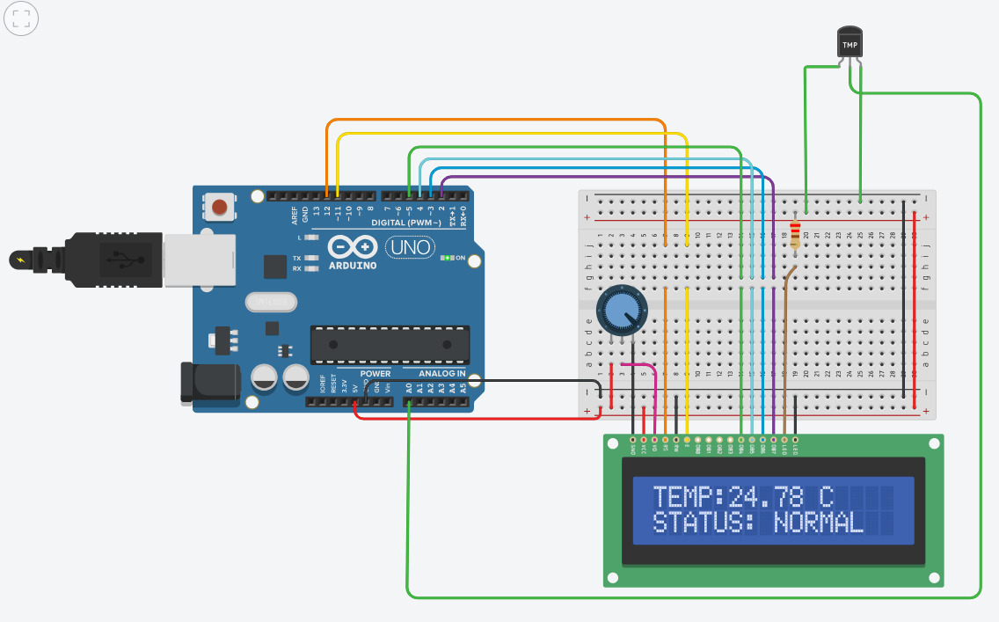

Figure 3.1: Tinkercad simulation of the Smart Temperature Monitoring System

The figure shows the simulated Smart Temperature Monitoring System implemented using an Arduino Uno, TMP36 temperature sensor, and 16×2 LCD. The TMP36 provides an analog voltage corresponding to the ambient temperature. The Arduino Uno reads and processes this signal and displays the calculated temperature and corresponding status on the LCD. In the shown simulation, the measured temperature is 24.78°C and the system identifies the condition as NORMAL.
3.5 Working Principle
The system works in the following sequence:
Step 1 — Temperature sensing
The TMP36 senses the surrounding temperature and generates an analog voltage proportional to the temperature.
Step 2 — Analog-to-digital conversion
The TMP36 output is connected to analog pin A0 of the Arduino Uno.
The Arduino's ADC converts the analog sensor voltage into a digital value.
Step 3 — Temperature calculation
The Arduino converts the ADC value into voltage and then calculates the temperature in degrees Celsius.
For the TMP36: Temperature = (Voltage - 0.5) \times 100.
The 0.5 V term represents the TMP36's nominal offset at 0°C, and its sensitivity is approximately 10 mV/°C.
Step 4 — Temperature classification
The Arduino compares the calculated temperature with predefined threshold values.
For this project:
Temperature | Status
Below 25°C | NORMAL
25°C – 35°C | WARNING
Above 35°C | ALERT
Step 5 — Display
The temperature and corresponding status are displayed on the 16×2 LCD.
3.6 Applications
The Smart Temperature Monitoring System can be applied in several areas.
1. Smart Homes: The system can monitor room temperature and can be extended to automatically control fans, air conditioners, or other appliances.
2. Greenhouses: Temperature monitoring can help maintain suitable environmental conditions for plants.
3. Industrial Monitoring: Temperature sensors can be used to monitor machinery, equipment, or industrial processes where excessive temperature could indicate a problem.
4. Server and Electronics Rooms: Temperature monitoring can be used to detect excessive heat around electronic equipment and server systems.
5. Storage Facilities: Temperature monitoring can be useful in storage areas where temperature-sensitive materials need to be maintained within specified conditions.
6. Healthcare Equipment: Temperature monitoring can be incorporated into certain medical and healthcare monitoring systems, depending on the required accuracy and sensor specifications.
7. Automotive Systems: Temperature sensing is widely used in vehicles for monitoring components and environmental conditions. More specialized automotive applications would use sensors and interfaces appropriate to automotive requirements.
4. Source Code with Comments
#include <LiquidCrystal.h>
// TMP36 connected to A0
const int temperaturePin = A0;
// LCD pins: RS, E, D4, D5, D6, D7
LiquidCrystal lcd(12, 11, 5, 4, 3, 2);
void setup()
{
// Initialize Serial Monitor
Serial.begin(9600);
// Initialize LCD
lcd.begin(16, 2);
// Startup message
lcd.setCursor(0, 0);
lcd.print("SMART TEMP");
lcd.setCursor(0, 1);
lcd.print("MONITOR");
Serial.println("Smart Temperature Monitor");
delay(2000);
lcd.clear();
}
void loop()
{
// Read TMP36 analog value
int sensorValue = analogRead(temperaturePin);
// Convert ADC reading into voltage
float voltage = sensorValue * (5.0 / 1023.0);
// Convert voltage into temperature in Celsius
float temperature = (voltage - 0.5) * 100.0;
// Display temperature in Serial Monitor
Serial.print("Temperature: ");
Serial.print(temperature);
Serial.print(" C | ");
lcd.clear();
if (temperature < 25.0)
{
// Normal temperature
Serial.println("Status: NORMAL");
lcd.setCursor(0, 0);
lcd.print("TEMP:");
lcd.print(temperature);
lcd.print(" C");
lcd.setCursor(0, 1);
lcd.print("STATUS: NORMAL");
}
else if (temperature <= 35.0)
{
// Warning temperature
Serial.println("Status: WARNING");
lcd.setCursor(0, 0);
lcd.print("TEMP:");
lcd.print(temperature);
lcd.print(" C");
lcd.setCursor(0, 1);
lcd.print("STATUS: WARNING");
}
else
{
// Critical temperature
Serial.println("Status: CRITICAL");
lcd.setCursor(0, 0);
lcd.print("TEMP:");
lcd.print(temperature);
lcd.print(" C");
lcd.setCursor(0, 1);
lcd.print("STATUS: ALERT!");
}
// Take a new reading every 1 second
delay(1000);
}

